- EfficientNet b0
Training Accuracy: 99.96%
Validation Accuracy: 51.87% (I average epoch 20-30 val accuracy)
Testing Accuracy: 48.41%
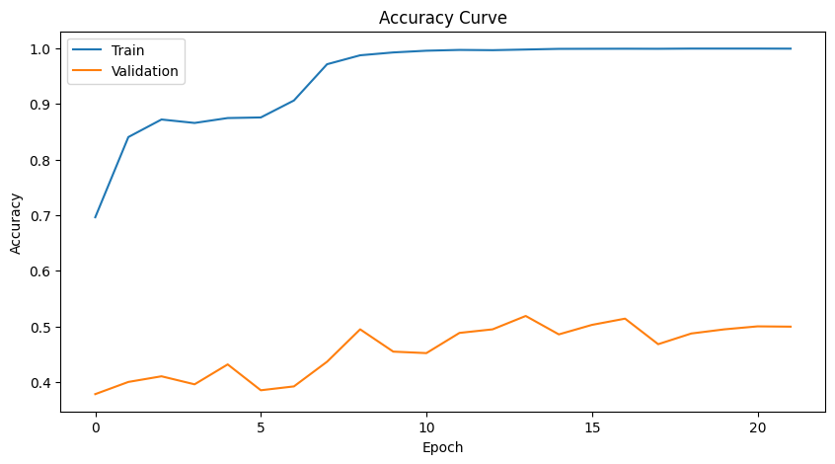
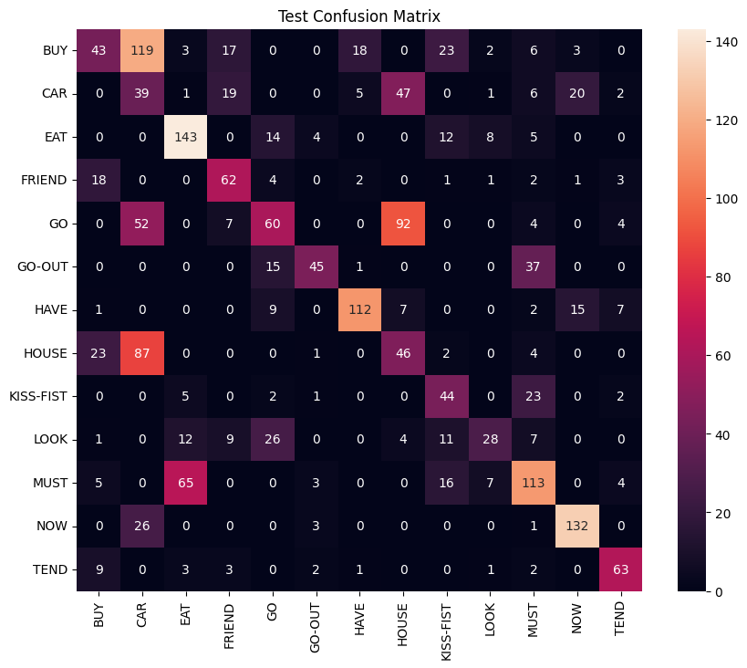

- Resnet-18
Training Accuracy: 99.59%
Validation Accuracy: 52.78%
Testing Accuracy: 45.65%
